Intercooler Faceoff part Deux: Champion 2010+ Gen 2.5 vs 997.2 / GT2RS
Standard Disclaimer: This testing was done on one car and represents my own findings. Your mileage may vary, what worked on my car may not work on yours. You may see different results. I assume no responsibility if you hurt yourself or your car.
After Tom@Champion threw down the gauntlet calling out 997.2 ICs and I found a new set of the Champion Motorsport 2010+ Gen 2.5 intercoolers for a very reasonable price and there isn’t much comparison data out there, I figure it was time for another intercooler faceoff.
Overall impressions of the Champion coolers: Construction wise, they are a d*mn work of art. They are the best I’ve seen fitment wise and the attention to detail all the way down to the hose clamps was impressive. They control inlet air temperatures (IATs) decently well and, though I did not send them off for independent flow testing, I think there’s enough info out there from GIAC (and Champion themselves) to indicate that they are a relatively low pressure drop design.
Some measurements on the Champion cooler:
Weight: 11.4 lbs (ea)
Core Length: 13.75”
Core Width: 8.625”
Core Thickness: 3.5”
Charge Rows: 11
Row Height: 0.41”
External Fin density: 19 fins per inch* (”front” row of fins, rows following it are independent & staggered)
Internal Fin density: 15 fins per inch* (”front” row of fins, row following it are independent & staggered)*
*Note: I’ve seen another intercooler fabricator count the first two sets of fins to get the staggering included in the fin density numbers on their coolers. By this method, these coolers would be 38 and 30 fins per inch, external and internal, respectively.
These appear to be the renowned Garrett intercooler cores that have been doing well on all types of platforms. Before you think of buying cores off the shelf and welding on some end tanks homebrew style, be advised that Garrett does not sell a core anywhere near this size and it will take significant effort to cut one down to size. I’m not sure where Champion sourced them but good on them as these are great cores. The only drawback is reports of reduced flow to radiators in front mounted applications due to the somewhat higher fin density –not a problem on a 996/997 turbo platform. Each of these coolers weighs 11.4 lbs, putting them each at 4.4 lbs heavier than 997.2s.
The cast inlet end tank appears very nicely done but the real winner is the CNC’d end tank, they should patent it. As far as I know, it’s the only end tank on the market that doesn’t require the flow in the top rows to make a >150 degree turn to get out of the cooler. This probably allows for more full use of the entire core and contributes to lower pressure drop.

Measurements from the 997.2 cooler:
Weight: 7.0 lbs (ea w/ Araldite on the end tanks)
Core Length: 13.25”
Core Width: 8.625”
Core Width: 3.25”
Charge Rows: 14
Row Height: 0.30”
External Fin Density: 22 fins per inch (staggered but offset from the same set of fins (perforated if you will))
Internal Fin Density: 19 fins per inch (same staggering method)

Some comparison pics:
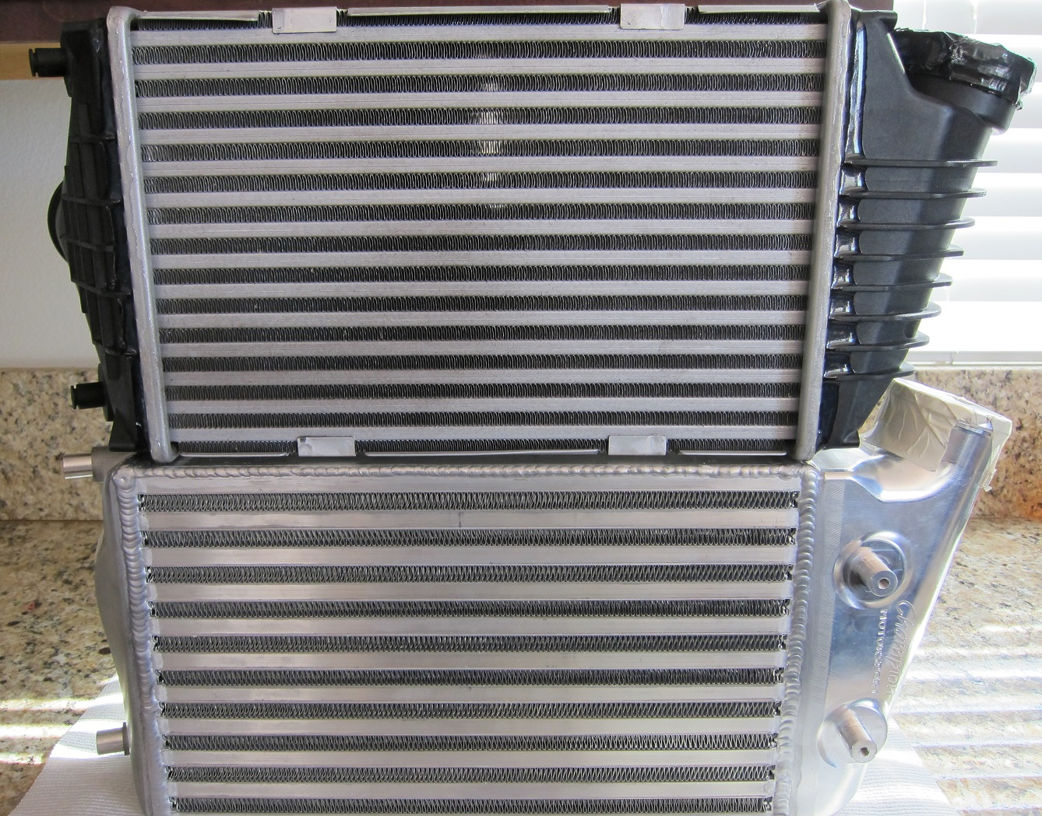

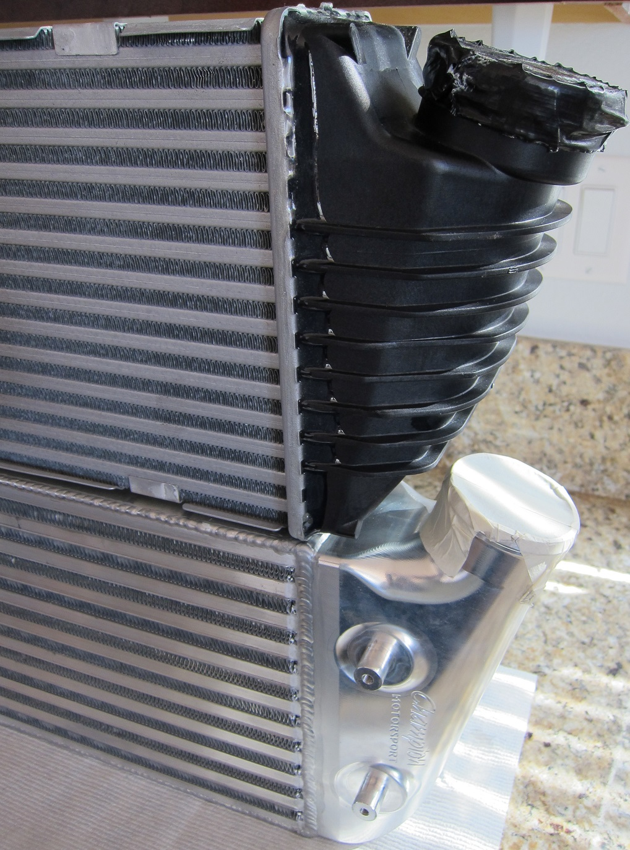

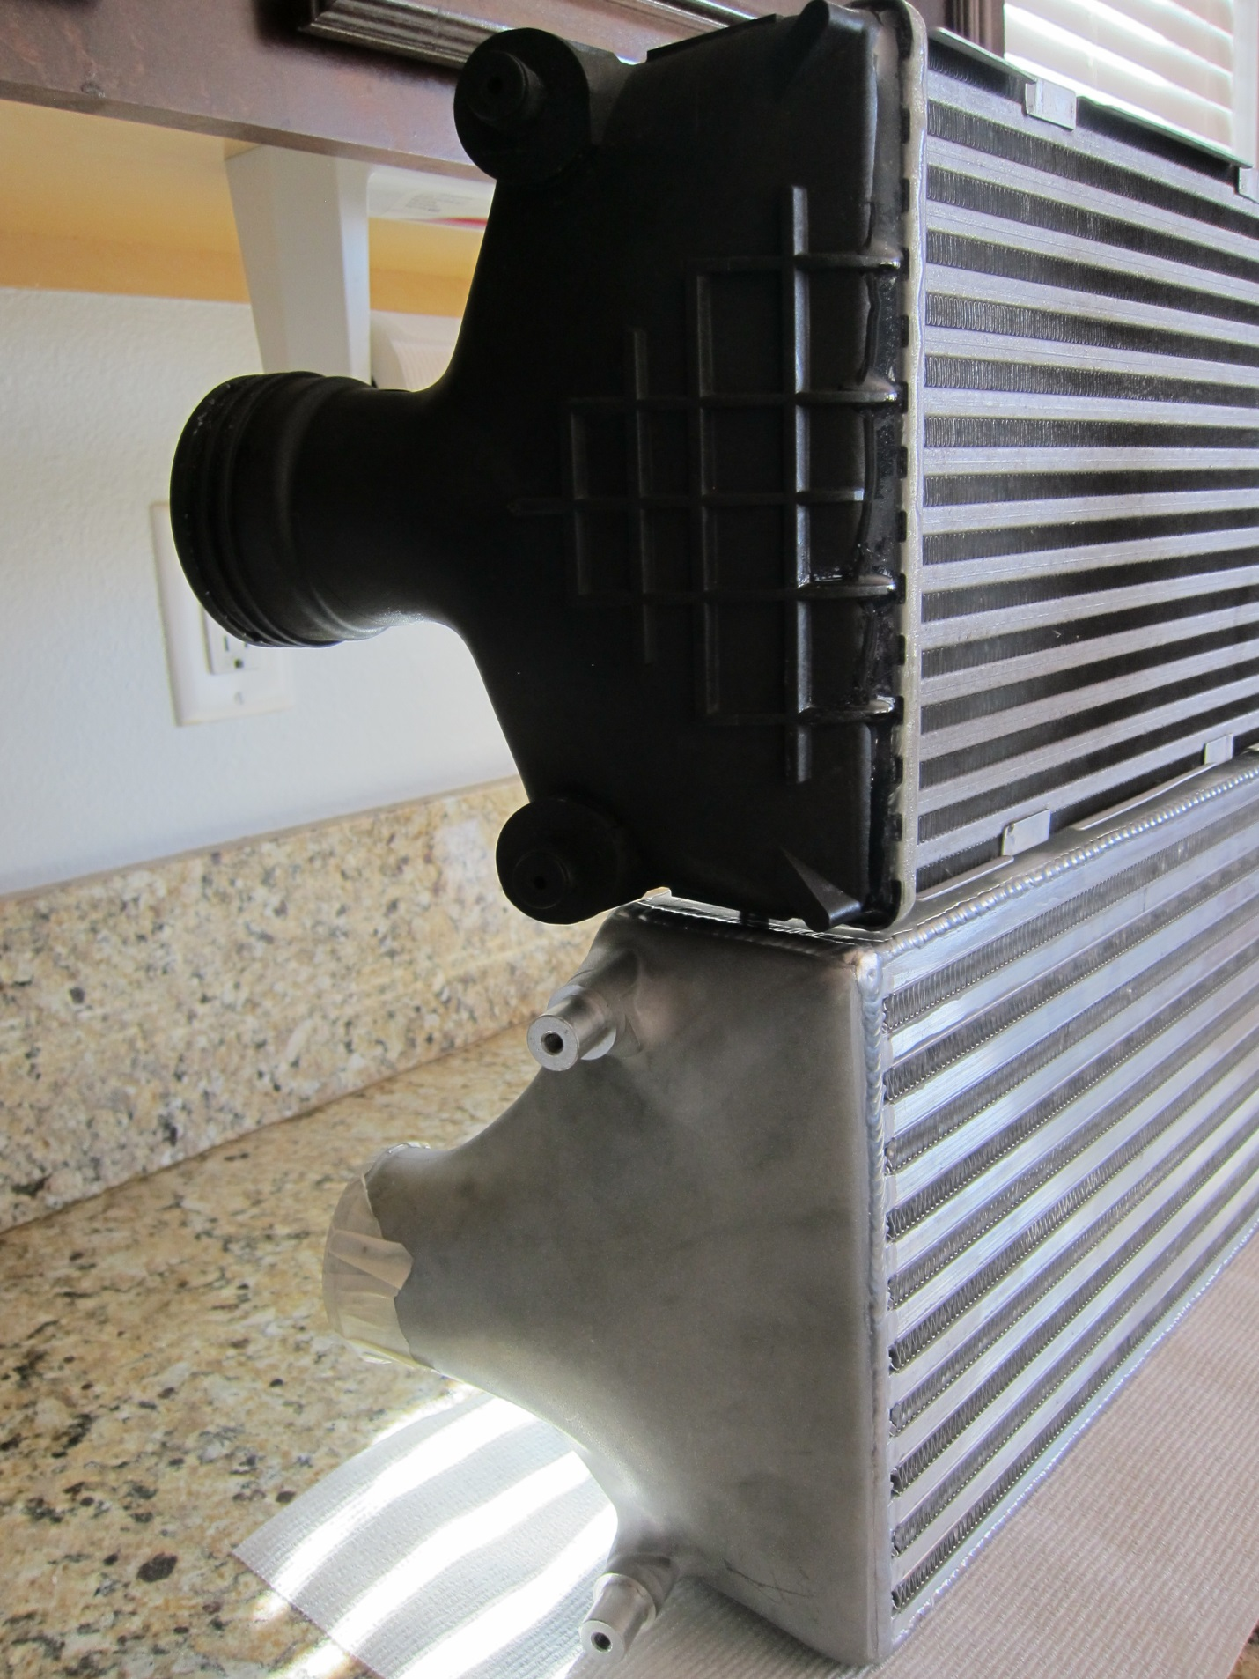

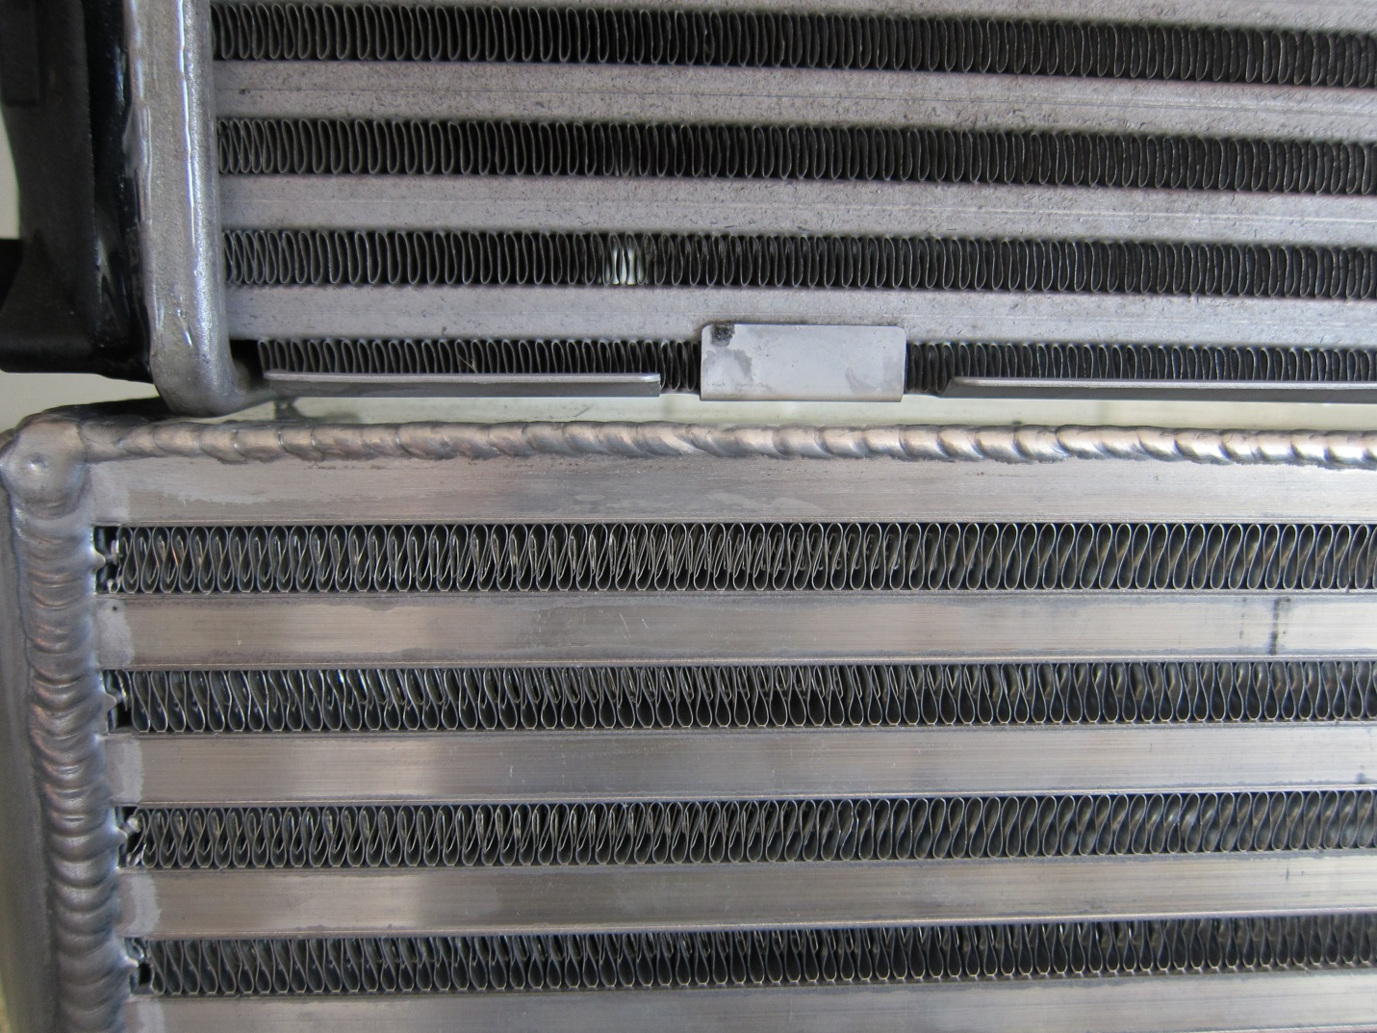

Installation:
It’s important to note that the kit I got was for a 997.2 and I installed and ran these on a 996. This means that there is 1 frame locating pin that isn’t used but the coolers still mounted solidly (similar to 997.2s on a 996). With my ducts already modded for the 997.2 intercoolers, install was again a breeze. If you’ve got stock coolers, you’ll need to grind down the inner lip on the inlet and outlet ducts like on pretty much any other aftermarket intercooler –this is a good thing as it allows manufacturers to use slightly wider cores. I put a good ¼” bead of clear silicone on all of the duct-to-cooler mating points to ensure a perfect seal. Good ducting is critical! The factory metal straps are retained.
Hoses are a different story because, as far as I know, Champion doesn’t have a kit for putting these on a 996tt. I had to get creative with a couple of adapters, but overall not too bad mating these up to my Forge upper hoses. It is great to be rid of the stock hoses connectors!
None of the install stuff applies to the 997 crowd, where these coolers are a no-hassle simple bolt-on and go.

The test setup:
2001 996 Turbo, 42k miles, fresh plugs & coils
Low clearance K16/2280 ETT Hybrids @ ~1.3-1.4 bar (60-130s vary from low 6s to mid 7s based on where, when & how I do the run) This indicates somewhere in the 600-650hp ballpark. Note these are the same compressors found on the 997 GT2, GT2 RS and the 997.2 turbo, just in a tighter compressor housing and with a slightly less restrictive hot-side.
EPL Tune
72lb Injectors
3.0” cat-less, non-louvered, non-chambered, non X Exhaust
2.5” Inlet pipes
AP Dual Snorkel Airbox
Forge IC hoses
105 octane (R+M)/2 gas
Sachs 764 Clutch
No boost leaks!

The test:
All done on a closed course in a 30+C desert environment.
Conditions: ~32C Alt: 29.95 DA ~5000’
Short term gains were tested by doing 60-130 mph pulls with a 3-4 shift in between. I chose the runs shown below because the ambient temps, barometer and starting IATs were similar for these pulls.

There was no conclusive IAT difference here. Neither cooler moved until 4th gear, or roughly 4 seconds into loading, then they each put on ~10C in 4th until redline. This is why you don’t test intercoolers on a dyno or with short pulls. Performance was the same. Don’t laugh too hard at my 60-130 time, it’s at 5000+ ft of density altitude.
How do these coolers do under more sustained loading? Longer term performance was tested by doing pulls from ~60-160mph (I ran the 997.2s a little further out in the chart below) to try and capture where the temps peaked. Ambient temps were within 1C on these pulls.
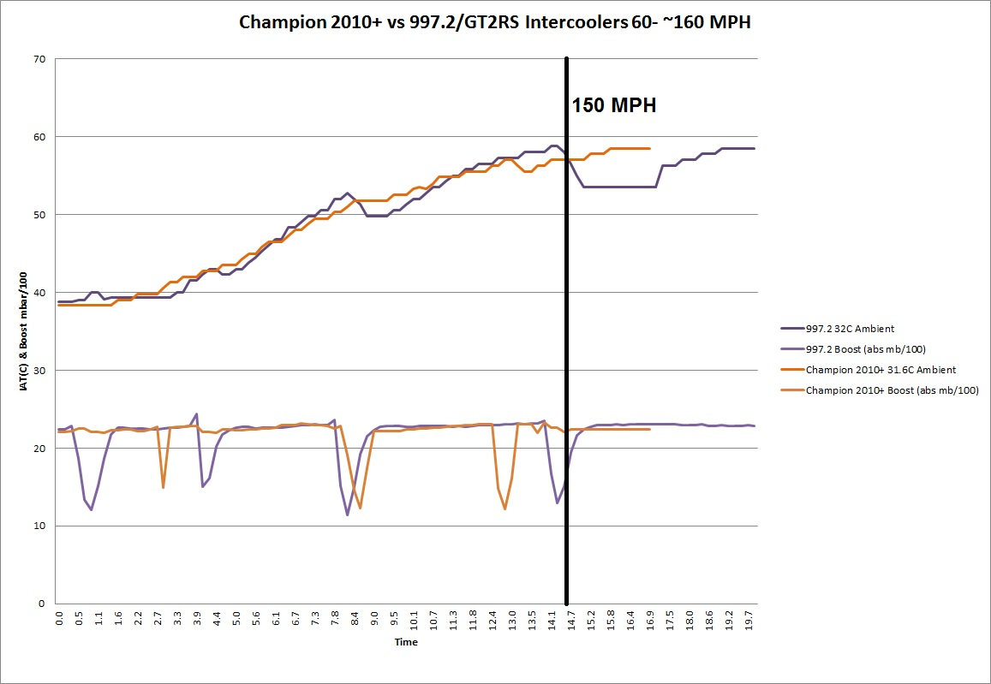

IAT-wise at 1.3-1.4 bar on Borg-Warner 2280 compressor wheels, these coolers are neck and neck. Don’t think for a second this is necessarily a bad thing. Combining this type of IAT control with a less restrictive cooler is a great recipe –very few coolers can out-cool the 997.2s under significant/sustained loading (you’d be surprised). The ones that can aren’t cheap. As I’ve said before, there’s only so much you can do when constrained to ~14” of core length. Expect IATs to remain within 30-40C of ambient with both of these coolers in most applications. Keep in mind these were tested in grueling desert conditions, expect to stay a bit closer to ambient if you’re in a cooler climate at similar boost levels. There was no appreciable difference in acceleration times between the two coolers, which is not surprising at my power level.
One more note worth mentioning on IATs: there is a comparison out there of an aftermarket intercooler kit vs stock 997.2 coolers “tested” doing short pulls on a chassis dyno with some electric fans blowing air on the coolers. Those setups in no way represent realistic loading or airflow over the car at really any speed and will not reflect what happens on the road or track. The “winner” of those tests will always be the cooler with the larger thermal mass. Do not conclude that since Champion IATs are similar to 997.2 IATs that this other aftermarket kit is automatically better than Champion. It may or may not be –relevant testing is needed. Would you test a coolant radiator doing short dyno pulls? Neither would I. You need to load the car for more than few seconds and log temps in a realistic airflow environment. ‘Nuff said on that.
Thermal recovery performance, particularly at higher speed, did ever-so-slightly go to the 997.2s, you can already see the recovery trend on the 997.2s at every shift, especially at the 5-6 shift. When the thermal loading disappears, even for a half-second during a shift, the 997.2s are eager to start recovering.
I took another look at recovery times by examining recovery time after a 60-130 pull. These runs were chosen because the speed was most similar winding down after the pull. I slowed from ~135 mph down to and held 55 mph at approximately the same rate. The ambient temps were 2.3ºC higher for the 997.2s but otherwise a very close comparison.

This is of course limited data but it points in the direction that the coolers are similar in recovery. The 997.2s are recovering a touch quicker with a slightly higher ambient temp but it’s not a massive difference here. It’s also important to note that none of the aftermarket coolers I’ve tested have recovered as quickly as the 997.2s, so it’s not a unique situation. Both of these coolers recovered more quickly than ETS 16 row. I’m wondering if it’s the one drawback of metal end-tanks. Heat that would otherwise remain in the core area to be whisked away by airflow may be propagating into the end tanks and contributing to the overall heat retention throughout the core after the loading is removed and the vehicle slows down. Again, the difference is slight. You will probably never notice unless you are logging both back to back or if you’re a serious road racer.
In summary:
Champion 2010+ “Pros” vs 997.2s: Brilliant construction out of the box, very similar IAT control to 997.2s, will support more hp / less restrictive setup, robust, completeness of kit, getting rid of the stock hose connections!
Champion 2010+ “Cons” vs 997.2s: price, slightly slower thermal recovery after loading
Commence personal opinion:
For 997.1 owners either cooler is a great upgrade over stock with the hot running VTGs (again, if you run 997.2 coolers you need to epoxy the end tanks to reduce chances of having to pull your bumper again down the road). The biggest tradeoff between the two being future headroom vs price. Road racers who will never exceed ~700hp would probably be better off spending the price difference on other things. For street, drag and road racers or others who want room to grow beyond 700hp or are really pushing their stock turbos, Champion provides a great option that you’ll never have to fiddle with again.
997.2 owners shouldn’t expect major changes in IATs. I’ve heard some reports of flashed 997.2s becoming more consistent and less prone to heat soaking after installing the Champion coolers. My data shows otherwise -unless their stock intercoolers were leaking, the factory hardware should be a touch less prone to heat-soaking. I think the benefit they’re seeing is, because the flash puts them closer to the edge of the compressor map, the less restrictive design is allowing lower turbine control duty cycles to reach target boost levels. This reduces work required on the turbine, bumps volumetric efficiency, takes them off of the ragged edge of the compressor map and probably frees up a few ponies and translates to a few tenths gained in acceleration trials. I know GIAC has seen lower DCs and is why they only offer their “9 sec” file to customers with the Champion coolers –the higher pressure loss from the 997.2 coolers puts the turbos off or at least on the edge of the compressor map. In short, if you’re turbo limited, and those running these 1.55 bar flashes on 997.2s probably are, these Champion coolers will let you safely push them a little further without having to do turbo swap surgery. On the flip side, you could probably upgrade the compressor wheels in the turbos for a similar price.
Theory aside, and because the test car wasn’t a 997, you can’t argue with the results the 997.2 Champion intercooler/GIAC tune bolt on packages are achieving in drag and roll racing events, particularly with the PDK trans. (search for username: longboarder)
Another plus for the 997.2 guys is that they can reasonably expect ~$1000 for their stock coolers, which effectively cuts 25% off the price of the Champion coolers and gets them under the $3000 mark.
So there you have it, Champion offers a higher flowing, all metal version of 997.2-like temperature control in a very complete kit that also does away with the stock hoses. In terms of IAT control and as intercoolers overall, neither cooler is the “best” on the market. Data dictates that crown still goes to the European coolers running specially brazed aerospace cores with upwards of 30 fpi. Unfortunately, these types of coolers also cost over $10000 USD. Like every mod, your intercooler choice will of course depend on your budget and goals for your car.

